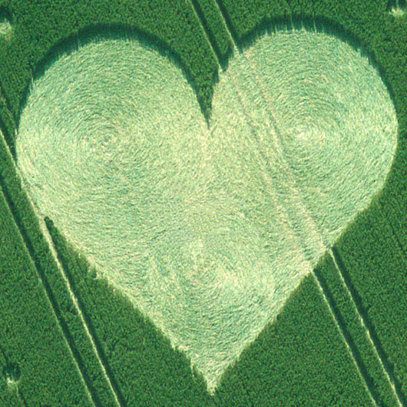
ICCI 2017 Registration

Salutation (Prof., Dr., Mr., Mrs., Miss., Ms etc):

First Name:

Family Name:

Institution:
(as you want it to appear on your badge)

Address for correspondence:

Country:

Email address (this will be used to confirm receipt of your registration and payment):

Phone number:

Are you a registered PhD student? Yes/No

Any special dietary or other requirements that we should be aware of:

I wish to present an oral presentation Yes/No

I wish to present a poster Yes/No

If offering a presentation or poster please complete and submit the Abstract form using the guidelines supplied.

I agree to pay UPM the sum of £………….. in registration fees with the reference ICCI2017_..........................

Signature: ……………………………………………………………. Date: …………………………

